**What is gluten free diet and foods to eat and avoid**

Before taking notes on what is gluten free diet and what food to eat and avoid, let us first talk about why are we calling it a diet? Is there really a gluten-free diet meal plan to follow or is it just a separation of gluten from our regular meals?

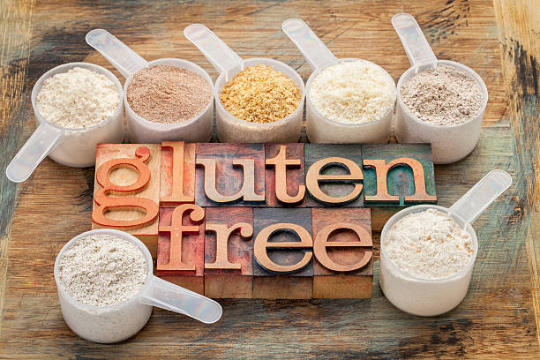Actually, gluten is nothing more than another ingredient that piles up to our nutrition intake amounts. One reason that makes it necessary to avoid gluten in our diet is side effects of gluten sensitivity. A gluten free diet chart become a necessity to indulge yourself in!

**What is gluten free diet? And what should be an ideal gluten free diet menu?**

A diet which avoids intake of major gluten food like wheat, barley, rye and substitutes it with gluten free diet menu including rice, corn, potato, soy, beans etc. is known as gluten free diet plan.

**Gluten free diet chart**

Here are some commonly used gluten free recipes to take in while providing your body a new and healthy start! Gluten free diet chart is as follows:

• Beans, seeds and nuts in their natural form (unprocessed and unpolished)

Legumes like lentils and peas are healthy while following a gluten free diet meal plan. They are present in nature as protein sources. Grab these gluten free foods instead of adding packaged diets in your list!

• Fresh eggs, poultry and fish (not bread-coated or marinated)

People love eating non-vegetarian food and guess what? There is no harm in it! This food is rich in proteins and fibre and helps in nourishment of body, adding to the list of gluten free diet meal plan.

• Fruits and vegetables

They fill up the natural form of nutrition our body lags when deficient in certain vital vitamins and minerals. Gluten free recipes including fruit and vegetable variants provide a healthy supper.

• Dairy products

Products like milk, ghee, butter, cheese are healthy to eat and are good for our bones and muscles. They provide a form of grease that oils up our bones so that they work smoothly. These gluten free food habits are a combination of healthy and tasty!

That might have answered the question: what us gluten free diet and how it benefits us. Not limited to this, gluten free diet plan aids the existing health record of our body!

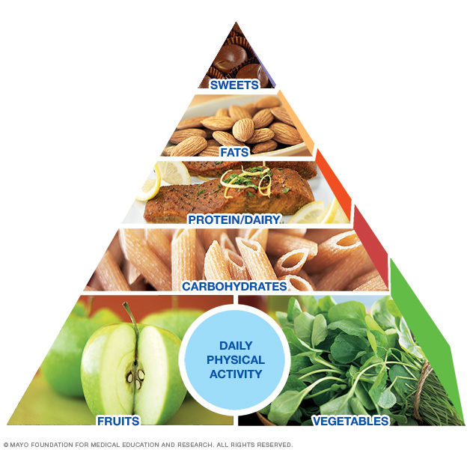

**Gluten free diet and weight loss**

Many researchers have proposed a theory based on various surveys conducted that gluten free diet is not usually a reason to increasing weight changes in our diets. But a few pounds decrease in weight after taking a gluten free diet is observed on a large scale. For obvious reasons, gluten is present in all fluffy-looking and luscious eateries, enough to make a person forget the damage it causes!

That's why gluten free diet and weight loss go hand in hand profiting both ways: first, in scheduling healthy eating habits. Second, by helping us avoid food that causes various restrictions in the long run. So, try gluten free diet and weight loss will follow definitely!

**What to avoid while on a gluten free diet meal plan?**

Following gluten free food must be eliminated permanently (or to maximum extent) to become a happy and healthy heart:

• breads

• cakes, candies and pies

• cereals

• cookies and crackers

• French fries

• pastas

• processed meat

• salad dressings

• sauces, including soy sauce

• seasoned rice mixes

• snack foods, such as potato chips

• self-basting poultry

• soups

Gluten free recipes are surely hard to pursue but once a gluten free diet plan becomes your routine, believe me! No barrier will be able to stop you from achieving size goals! A gluten free diet menu awaits.